Title of your article no more than 15 words
John Doe^{*,a} , Smith Jones^{b}, Ananva Sharmaª
ª: University of City name, Country. ^{b} University of City 2, Country 2
E-mail*: j.doe@gmail.com. (corresponding author mail ID)

Abstract
This document gives you guidelines on preparing manuscripts for submission to CRC-SPAST Proceedings, and also provides the rough format of finished articles in order to estimate the length of your article. Article should not exceed 5 pages in length. The first word of the title should be capitalised, with all other words lowercase. Please avoid using the words ‘new’ and ‘novel’, as well as function words such as ‘the’, ‘a’ and ‘an’. A full list of author names should be placed under the title, using the following style: initials (separated by full stops) and family name. Chinese-style names can be printed in full; therefore, they should be typed as the author wishes his/her name to appear. Author names should be separated by a comma apart from the final name, which should, instead, be preceded by ‘and’ (see the example above). The Abstract should follow, and must be: indented 1 cm; Times New Roman; font size 10; one paragraph; and should not exceed approximately 150 words. It must not cite any references, and any acronyms used in the Abstract must be expanded.
Keywords: Crisis, ownership, variables,

Introduction
The main text should be set in a two-column format, with a column width of 8.7cm and a central space of 1.06cm. Please use
10 pt. Times New Roman font with a line spacing of 1.1, and please number all pages. Each submission should have clearly headed Sections in the style shown, especially an Introduction, Conclusion, and References Section. New sections should be separated by a blank line, and paragraphs within the Sections indented by 0.3cm.
The first instance of all acronyms within the main text should be expanded, with the acronym defined after it in brackets, as follows: ‘electromagnetic interference (EMI)’. The expansion should not be capitalised, unless it contains a word that is normally capitalised, i.e. ‘fibre Bragg grating (FBG)’. Once the acronym has been expanded in the main text, all future instances can be shortened to the defined acronym; i.e. ‘EMI’.
All of the References present in the References Section must be cited in the main text, in numerical order and in square brackets – i.e. ‘(Brockman,et al., 2014)’. Multiple references can be bracketed together, for example ‘(Brockman et al., 2014; Cella, C. (2009), Chuang, H. (2020))’. Figures and Tables must be embedded within the main text, and must also be cited in numerical order. Tables should be labelled ‘Table 1’, ‘Table 2’ etc. and Figures should be labelled, for instance, ‘Fig. 1’ and ‘Fig. 2’, with any sub-Figures labelled as follows: ‘Fig. 3a’, ‘Fig. 4c’ and so on. Figures that contain sub-Figures can be cited as a whole
(e.g. ‘Fig. 1 shows…’), or separately (e.g. ‘Fig. 1a shows…’) – if citing sub-Figures separately, please ensure that all parts are cited.

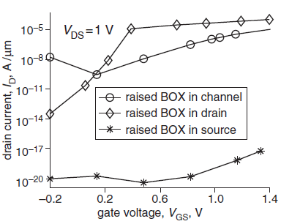Presentation of Figures and Tables: As stated above, Figures and Tables must be embedded within the main text. They cannot be set across two columns, and must be clearly readable when viewing the manuscript at 100% zoom, or when printed. Figures and Tables must also be separated from the main text with a blank line.
Fig. 1 Zero should always be written ‘0’ – do not include decimal places after zero (i.e. not ‘0.0’); set all legends in boxes within the Figure.

Please ensure that Figures are clearly labelled, as discussed above, placed near to where they are cited and that they are of good quality; i.e. clear to understand and not blurry. CRC-SPAST proceedings is available in colour online, but please ensure that Figures are understandable when viewed in black and white. Also note that algorithms should be treated standalone, i.e. not treated as a Figure.
Note: if possible, please try to use composite figures instead of stand-alone figures.

Fig. 1 Zero should always be written ‘0’ – do not include decimal places after zero (i.e. not ‘0.0’); set all legends in boxes within the Figure.

Please ensure all Tables are cited in numerical order, as with the Figures and References. Unlike Figure captions, Table captions are placed above the corresponding Table, and are not italicised. If all values in a column use the same units, include this in the column heading in brackets rather than after each value.

To insert figures always use drawing canvas the example is shown page 2 of this document.

Information on equations: All numbered equations such as (1), below, should be referred to in the main text using the bracketed number only. For example, ‘I in (1) signifies the area’. Numbered equations or substantial maths should be set on a separate line from the text, as follows:
${SR}_{it} = α + β1{OC}_{it} +β2{FS}_{it} + β3{FA}_{it} + β4{FR}_{it} + β5{FP}_{it} + β6{LEV}_{it} + β7{LIQ}_{it}$+
β8${DP}_{it}+ε_{it}$…………………………………………………. (1)
${SR}_{it} = α + β1{IO}_{it}+ β2{FS}_{it} + β3{FA}_{it} + β4{FR}_{it} + β5{FP}_{it} + β6{LEV}_{it} + β7{LIQ}_{it}$+
β8${DP}_{it} + ε_{it}$ …………………………………………………. (2)

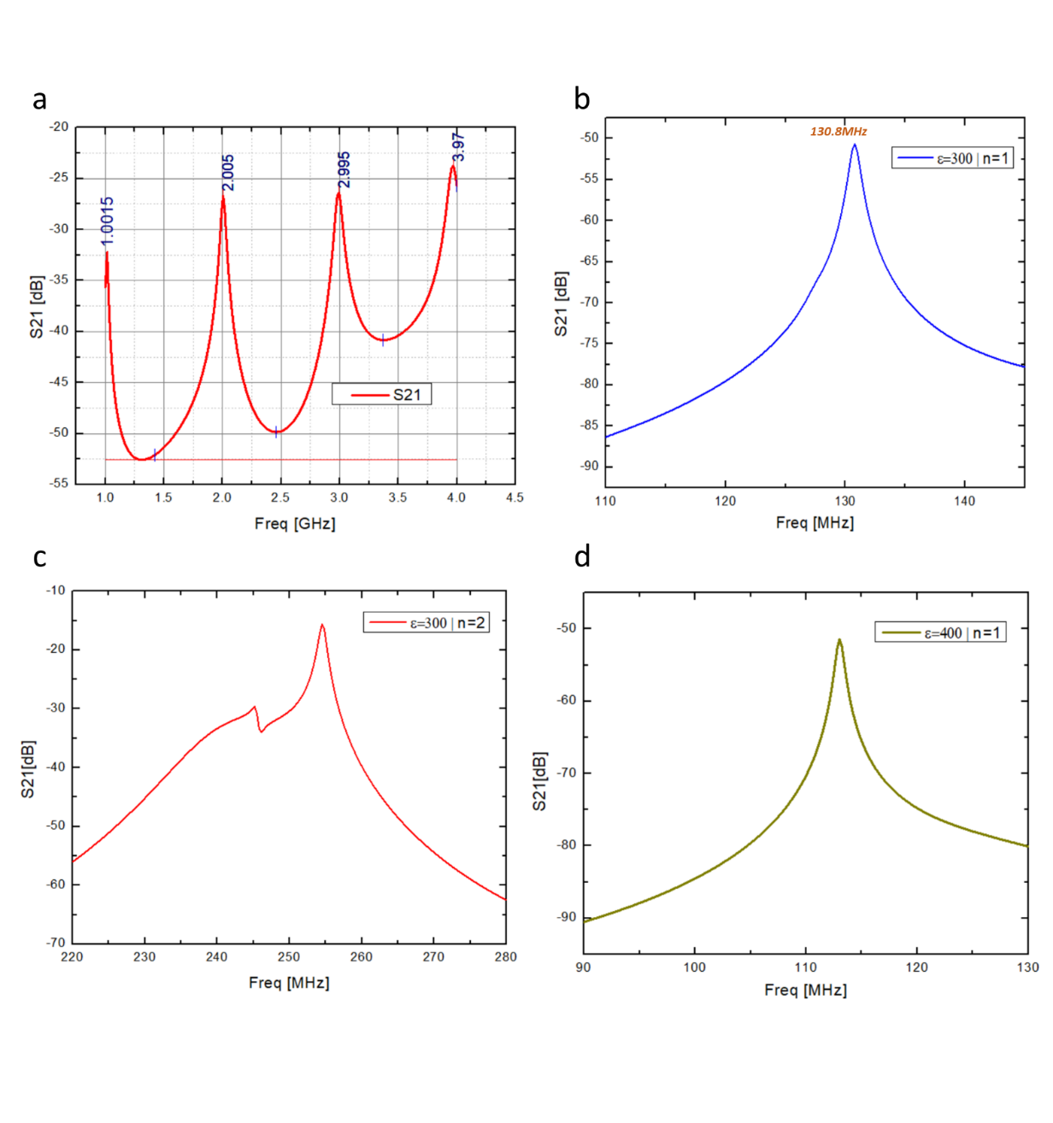
Fig. 2 An example of a composite figure (a) subfigure describing another figure (b) subfigure describing another figure (c)subfigure describing another figure (d) Sub-captions can be placed top left/right corners of each figure
Equation editors can be used, as long as they are in English. All variables must be defined, e.g. ‘the apex angles ’. If an equation is too long to fit on a single line, then split it over two lines, as follows:

Please pay attention to the use of italics and upright font: it is important that variables are set in italics, with non-variables and labels in upright. For example, R denotes resistor while R denotes resistance.

Please Note that References to submitted works cannot be included unless they have been accepted for publication. In the case of PhD theses, please provide as much information as possible, especially the relevant university.
Table I. Title of the table
Quantity | Measure | Mock | Table | For | illustration
W | 7 | 8 | 9 | 1E4 | 1E3
8.0987 | 0.01873 | Ω | τ | Y | T
≈ | -NA- | - | 0 | + | 2

Information on Author affiliations: Affiliations appear after the Conclusion and Acknowledgments Section (please see below). Please give the full affiliations of all authors. It must also be indicated which author is the corresponding author by including their e-mail address with their affiliation. Only one e-mail address can be published at the end of a manuscript. This e-mail will be published in the journal, as well as used for editorial work. If authors wish to change the e-mail address, or the author’s order of appearance, we will require email verification from all co-authors.

Conclusion: The Conclusion must be clearly marked as shown. When referring to other Sections in the Letter, please use the Section heading, or describe the relevant Section as the ‘following’ or ‘preceding’ Section in relation to the current Section in the text.

Acknowledgments: This Section is optional but can be used to recognise the support from certain funds or organisations, for example: ‘This work was supported by *insert organisation here* (grant ABCD-1234X)’. Please try to avoid personal acknowledgments, such as individuals, and please do not include any thanks to the Editorial staff.

Manuscripts with incorrect email ID and incomplete author details would be rejected without further scope for peer review.

References
Brockman, P., French, D. and Tamm, C. (2014). REIT organizational structure, institutional ownership, and stock performance. J. Real Estate Portf. Manag. 20(1):21 36.
Cella, C. (2009). Institutional investors and corporate investment. United Sates: Indiana University, Kelley School of Business.
Chuang, H. (2020). The impacts of institutional ownership on stock returns. Empir. Econ. 58(2):507 533.
Clark, G. L. and Wójcik, D. (2005). Financial valuation of the German model: the negative relationship between ownership concentration and stock market returns, 1997–2001. Econ. Geogr. 81(1):11 29.
Dasgupta, A., Prat, A. and Verardo, M. (2011). Institutional trade persistence and long‐term equity returns. J. Finance. 66(2):635 653.
Demsetz, H. and Lehn, K. (1985). The structure of corporate ownership: causes and consequences. J. Polit. Econ. 93(6):1155 1177.
Dyakov, T. and Wipplinger, E. (2020). Institutional ownership and future stock returns: an international perspective. Int. Rev. Finance. 20(1):235 245.
Gompers, P. A. and Metrick, A. (2001). Institutional investors and equity prices. Q. J. Econ. 116(1):229 259.
Han, K.C. and Suk, D.Y. (1998). The effect of ownership structure on firm performance: Additional evidence. Rev. Financ. Econ. 7(2):143 155.
Kennedy, P. (1985). A Guide to Econometrics, MIT Press, Cambridge.
La Porta, R., Lopez‐de‐Silanes, F., and Shleifer, A. (1999). Corporate ownership around the world. J. Finance. 54(2):471 517.
Manawaduge, A. S., Zoysa, A., and Rudkin, K. M. (2009). Performance implication of ownership structure and ownership concentration: Evidence from Sri Lankan firms. Paper presented at the Performance Management Association Conference. Dunedin, New Zealand.
The below line is approximately the maximum length of a manuscript allowed (if it were to fill all five pages).
Important Criteria of immediate rejection:
1. No more than 5 pages allowed including figures and references.
2. No more than 10 references allowed per article.
3. Self-citation: Citing more than three of one’s own articles would lead to immediate rejection unless it’s a short review article.
4. Figure captions must be clear and of similar sizes to the font size in the rest of the article. Failure to comply with norms would lead to immediate rejection.
5. Figure’s Length and Width aspect ratios must be locked else immediate rejection would be sent out to authors.
6. References must have year clearly mentioned.
7. Incorrect grammar would lead to rejection.
8. Failure to comply with less than 12% similarity index(plagiarism) would lead to immediate rejection.
This document is intended as a guide for format and length; your manuscript will not be copyedited post acceptance so please ensure all formatting standards are met. The total word count should not exceed 4000 word

